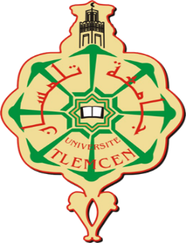
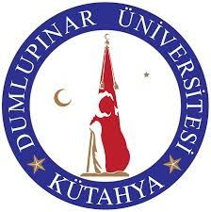

UNIVERSITY ABOUBEKR BELKAID
INTERNATIONAL RELATIONS DEPARTMENT
ERASMUS+ INTERNATIONAL CREDIT MOBILITY (KA107)
STAFF MOBILITY
APPLICATION CALL FOR ACADEMIC YEAR 2018-2019

ERASMUS+ International Credit Mobility (KA107)

Within the framework of ERASMUS+ International Credit Mobility (KA107), all staff employed in foreign higher education institutions (on condition that the higher education institutions signed a bilateral agreement) can participate in Erasmus+ Staff Mobility Programme. This mobility includes teaching and training activities which the staffs authorized in one higher education institution will perform in another higher education institution which is a party of ERASMUS+ International Credit Mobility (KA107) Agreement.

The Staff Mobility period consists of 7 days for each of 1 staff for teaching mobility and 7 daysfor each of 1 staff for training mobility from the departments of Chemistry, English Language and Literature, Industrial Engineering, Civil Engineering,History, Sociology, Physics and Mathematics.
Academic activities of academic staff cannot be less than total eight hours during the mobility. In hourly calculation of the activities performed by academic staff, courses are considered. In the case that course hours do not complete eight hours, academic activities like seminars, panels or conferences are evaluated in this context. Academic staff mobility plans which do not contain lectures cannot be regarded as mobilities. Within the training activity, there is no certain hours mentioned in the Guide Books; however, it is better to determine the training activities before and state them in the Training Programme. If a staff terminates his/her mobility without completing at least 5 days, the mobility will be regarded invalid.

3. Staff Grants in ERASMUS+ International Credit Mobility (KA107)

Incoming staffs from other countries to Turkish higher education institutions are granted according to the ratios determined by European Commission. In terms of the grants that will be paid to the staffs, 100% of the scholarship amount is paid when they come to host institution. Incoming ERASMUS+ International Credit Mobility Staff will be granted with 140 € per day for 7 days. Besides, s/he will have 360 € as a travelling cost.

Application Requirements of ERASMUS+ International Credit Mobility
- The staffs should have at least B1 level competence in English language.
- If the staff has a disability, s/he may be prioritized.
- If the staff applies for the first time, s/he should be prioritized.
- In training mobility, administrative staffs can be prioritized.

Application Documents for Incoming Staffs
- Staff Application Form
- Curriculum vitae (CV)
- Articles in the related area
- Projects as a coordinator and/or participant
- Academic Portfolio (including courses, seminars, work plan in the related area)
- Document showing language level (if exists)
- Scanned form of Identity Card

ERASMUS+ International Credit Mobility SCHEDULE

- Call for Mobility in Higher Education Institution | The duration should be at least 20 days.
- Receiving the applications for the Mobility Programme | The duration should be at least 15 days.
- Announcement of the exam places
- Written and oral exams
- Assessment of applications
- Announcement of assessment results
- Reclamation period | The duration should be at least 5 days.

