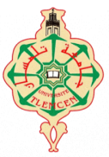
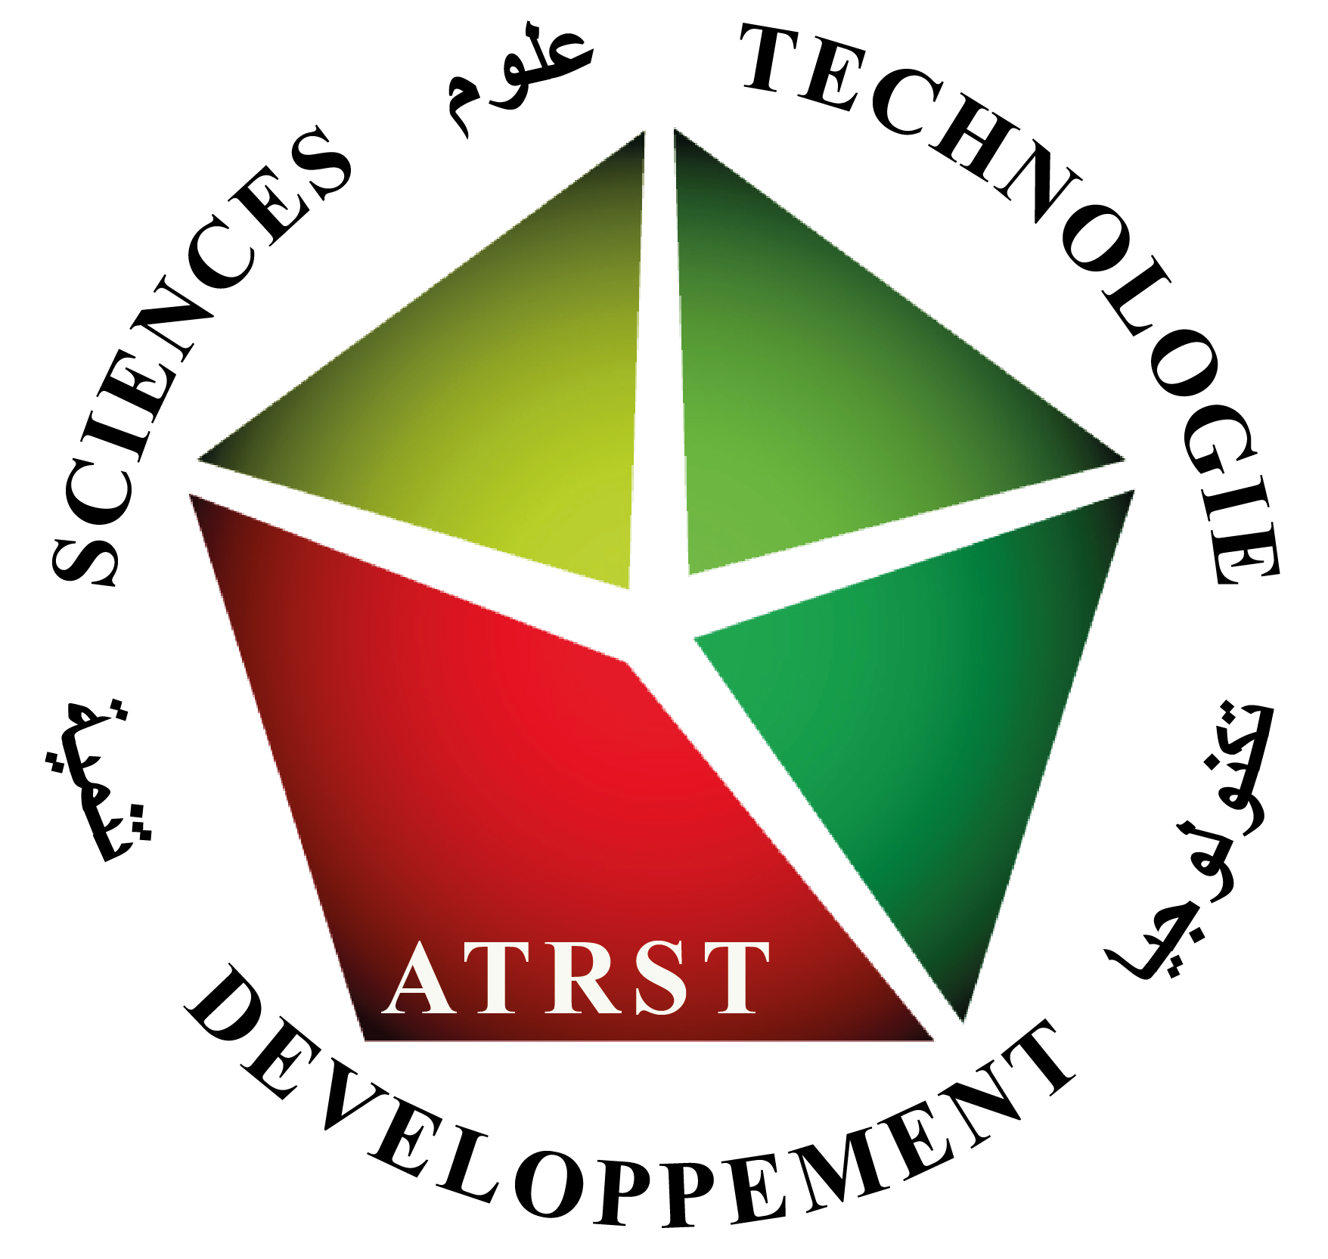
People's Democratic Republic of Algeria
University Abou Bekr Belkaid-Tlemcen
Faculty of Sciences
Department of Chemistry
Laboratory of Separation and Purification Technologies

1st National Symposium on
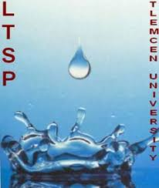
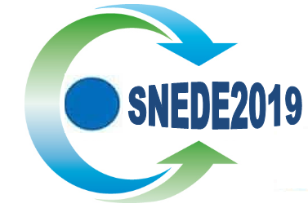
WATER, WASTE, AND ENVIRONMENT
Tlemcen, November 18-20, 2019

Thematic
Theme 1: Wastewater "Quality, Pollution, Toxicology and Impact, Treatment and Recovery".
Theme 2: Solid waste "Collection, selective sorting, management and impact, treatment, recovery and recycling".
Theme 3: Pollution: Air, Soil and Sediments.
Theme 4: Extraction techniques for organic and inorganic pollutants.

