**Saturday November 23rd , 2019**

* **Auditorium/ welcome and registration/ preparation of posters.**
* **Official opening ceremony.**

**Plenary lecture I**

**Pr Karima KHARROUB:** Procaryotes des environnements extrêmes algériens: état de l'art.

**Plenary lecture II**

**Pr** **María Isabel GONZÁLEZ SISO:** Metagenomics of hot springs in Galicia (Spain): Microbial diversity and novel thermozymes.

**Plenary lecture III**

**Pr Gael ERAUSO:** Serpentinization and microbial life: the Prony Hydrothermal Field, a model of study.

**Sunday November 24th, 2019**

**Plenary lecture IV**

**Pr Mouloud KECHA**: Metabolite profile of marine-derived endophytic *Streptomyces* and evaluation of culture conditions on antibacterial activity against MRSA.

**Plenary lecture V**

**Pr Ameur CHERIF**: Extremophilic bacteria as relevant sustainable solution for plant growth promotion in arid lands: current knowledge and future perspectives.

**Plenary lecture VI**

**Pr Hafeda HASSAINE :** Les biofilms bactériens: une cause majeure de résistance et d'infections associées aux soins.

**Awards and Symposium Closing Ceremony**

**Program**

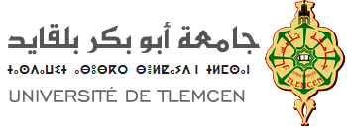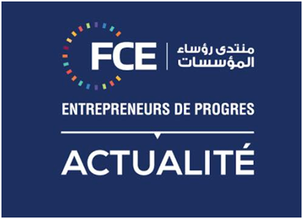



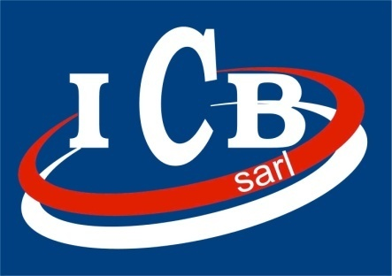

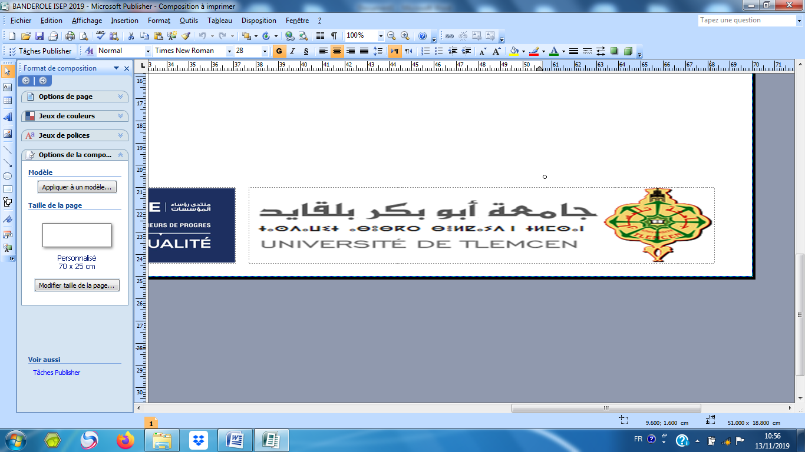

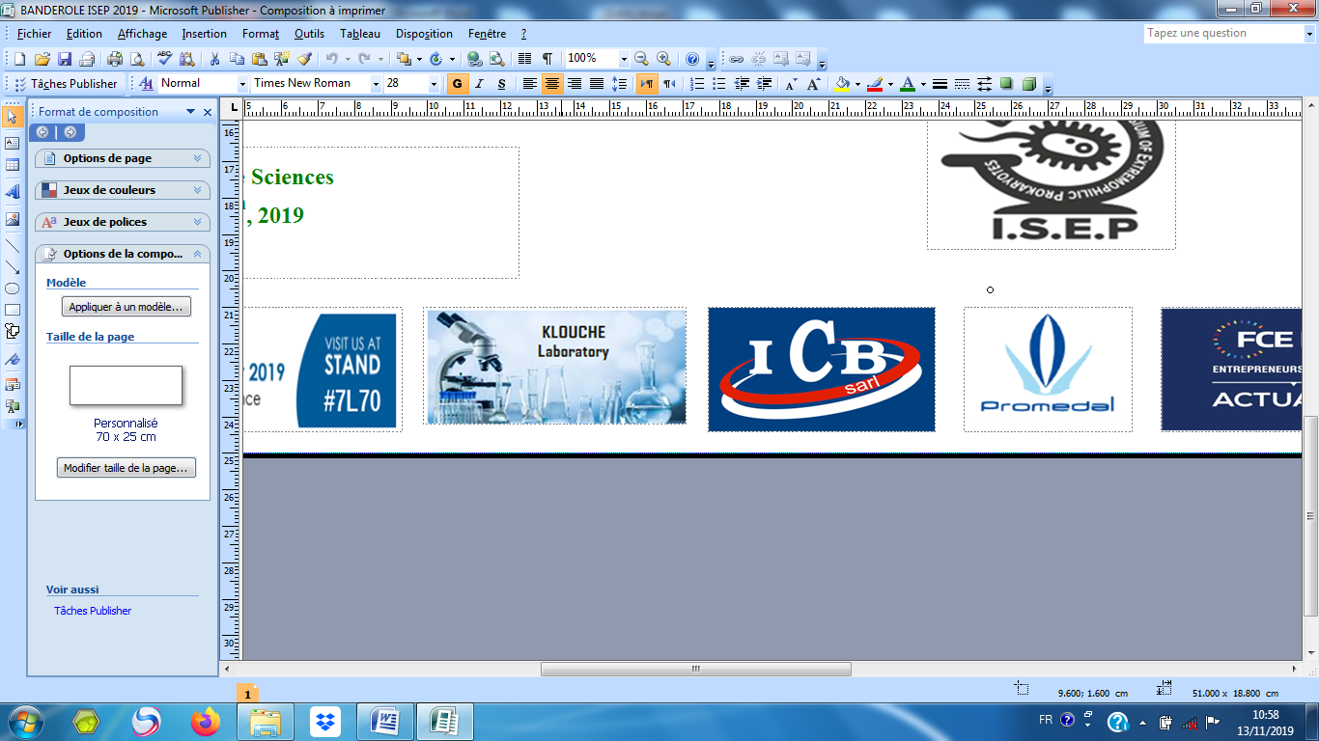

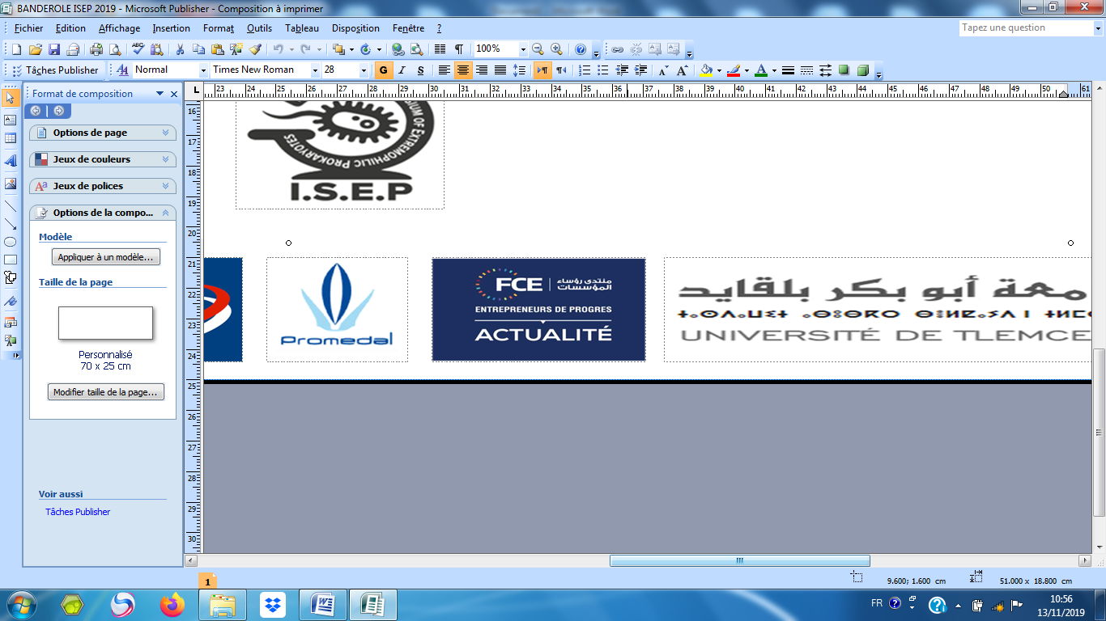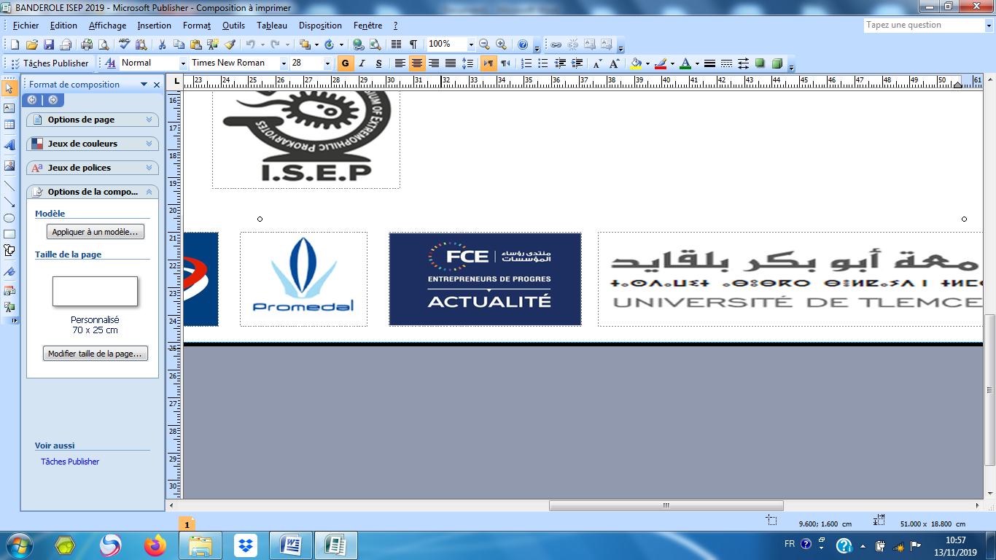

**PEOPLE’S DEMOCRATIC REPUBLIC OF ALGERIA  
MINISTRY OF HIGHER EDUCATION AND SCIENTIFIC RESEARCH  
ABOU BEKR BELKAÏD UNIVERSITY OF TLEMCEN**

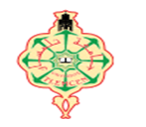

**Laboratory of Applied Microbiology in Food, Biomedical and Environment (LAMAABE)**

**And**

**Faculty of Nature and Life, Earth and Universe Sciences, Abou Bekr Belkaïd University of Tlemcen**

**Co-organize**

**The 1st International Symposium**

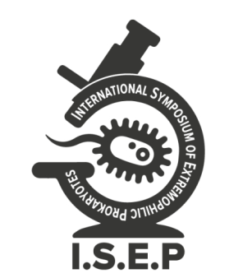

**Extremophilic Prokaryotes:**

**From Diversity to Biotechnology**

**ISEP-2019**

**Auditorium of Faculty of Nature and Life, Earth and Universe Sciences (SNV/STU) Tlemcen, November 23rd – 24th, 2019**

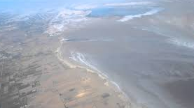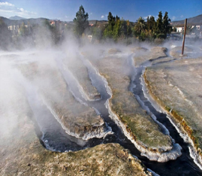

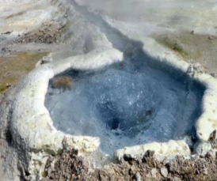

* **Microbial diversity of extreme environments**
* **Adaptation and cellular processes**
* **Biotechnology, Bioactive molecules**
* **Various**

**Topics**

**Honorary Assistance**

Pr., BOUCHERIT Kebir, Rector of Tlemcen University- Algeria.

Pr. MEGNOUNIF Abdellatif, Vice Rector of External Relation (VREX), Tlemcen University- Algeria.

Pr BACHIR Redouan, Vice Rector for Post Graduation , Tlemcen University- Algeria.

Pr BOUCHERIT Zahia, Tlemcen University- Algeria.

Pr MASMOUDI Ahmed Slahedine, University of Manouba-Tunisia.

Pr LEIRO VIDAL José Manuel, University of Santiago De Compostela, Spain.

* Mrs KLOUCHE KHELIL Nihel Amina, Pr. Tlemcen University- Algeria.
* Mrs BENCHOUK Samia , Dr, Tlemcen University- Algeria.
* Mr MESLI Amine, Dr, Tlemcen University- Algeria.
* Ms AISSAOUI Nadia Dr, Tlemcen University- Algeria.
* Mrs ARAB Mounia Dr, Tlemcen University- Algeria.
* Mrs BELAHCEN Chafika Dr,Chlef University-Algeria.
* Mrs BELLIFA Samia Dr, Tlemcen University- Algeria.
* Mr BENZIANE Mohammed Yacine (PhD. LAMMABE, Tlemcen University- Algeria)
* Ms BOUKEROUI Yasmina (PhD. LAMMABE, Tlemcen University- Algeria)
* Ms DJEBAH Fatima(PhD. LAMMABE, Tlemcen University- Algeria)
* Mrs GAOUAR Sarah (PhD. LAMMABE, Tlemcen University- Algeria)
* Ms GRIBI Kahina (PhD. LAMMABE, Tlemcen University- Algeria)
* Mrs NAS Fatima (PhD. Tlemcen University- Algeria).
* Ms MEDJAHEDI Khadidja(PhD. LAMMABE, Tlemcen University- Algeria)
* Ms ZERAOULIA Manel(PhD. Tlemcen University- Algeria)
* Mrs ZERROUKI Hanane(PhD. LAMMABE, Tlemcen University- Algeria)

**Organizing Committee**

**President**

Pr. KLOUCHE KHELIL Nihel Amina, Tlemcen University- Algeria.

**National Members**

Pr. MOKHTARI Nassima, Tlemcen University- Algeria.

Pr. HASSAINE Hafeda, Tlemcen University- Algeria.

Pr KHARROUB Karima, Constantine University-Algeria

Dr STAMBOULI Hassiba, Tlemcen University- Algeria.

Pr MOUSSA BOUDJEMAA Boumedien, Tlemcen University - Algeria.

Pr BENDAHOU Mourad, Tlemcen University - Algeria.

Pr. KECHA Mouloud , Bejaia University-Algeria.

Dr BOUBLENZA Lamia, Tlemcen University - Algeria.

Dr AISSAOUI Nadia, Tlemcen University - Algeria.

Dr ARAB Mounia, Tlemcen University - Algeria.

Dr. AZZI Rachid, Tlemcen University- Algeria.

**International Members**

Pr. GONZÁLEZ SISO María Isabel, University of Coruna, Spain.

Pr. CHERIF Ameur, University of Manouba-Tunisia.

Pr. ERAUSO Gael University of Aix-Marseille, France.

**Scientific Committee**